Name – Rakshak Dhone

PRN- 22311129

Roll No - 282037

**Assignment -3**

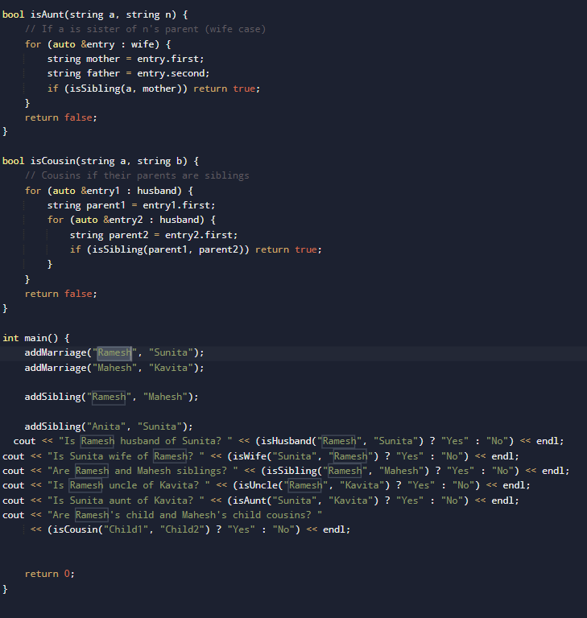**c++ implementation:**

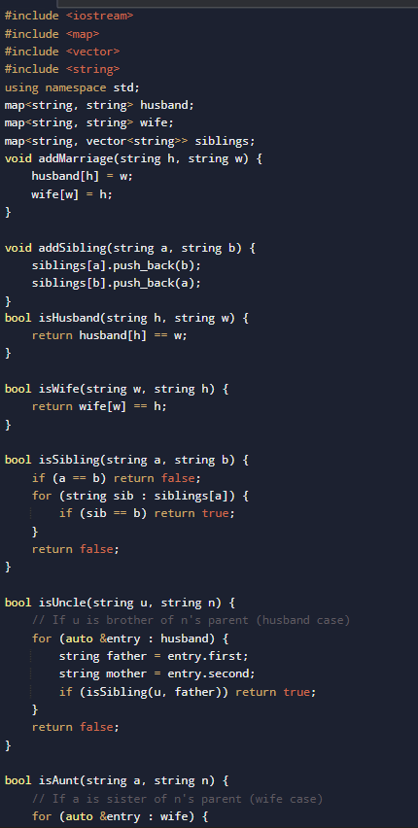

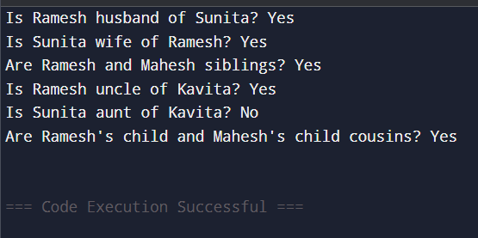Output: